Created By: Brijesh Jaiswal DT 20200507
Bug: - Project View Filter out option is not working properly.
Case – For example here I have created ITInfra and retail POS and main/head project. Now there are several subprojects are there like inside ITInfra FY2020-21 a. Asset Maintenance,
b. Backup Activity etc and another main/head project is Retail POS and inside it we have around 4 sub projects.

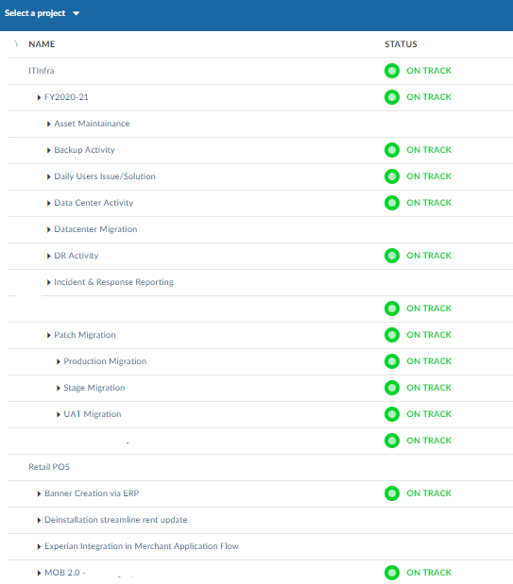

Scenario -1 – I want to remove full IT Infra with its sub project so that only Retail POS will be visible. So, I chosen the below listed option. I have checked by selecting “is not” as well as “doesn’t contain” option. But unfortunately, it didn’t work. Well I also tried by filtering the same with identifier name but it failed to work as expected.
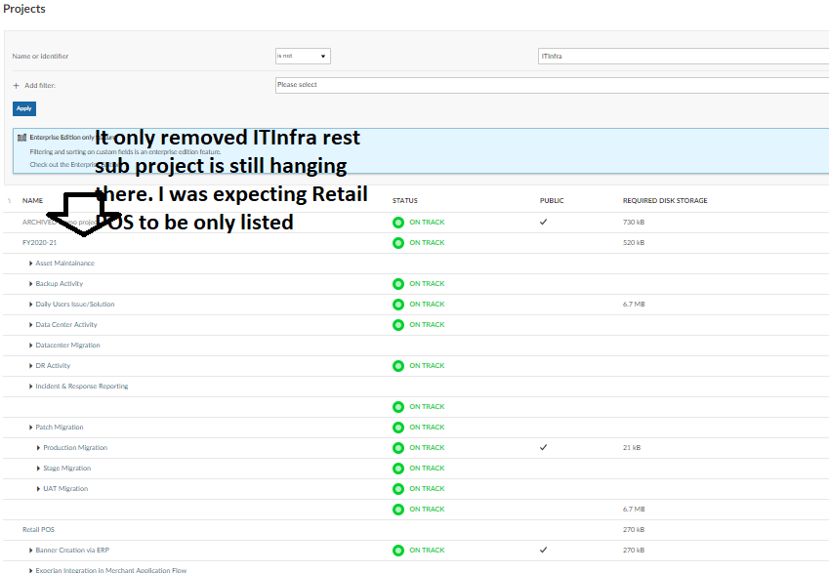

Expectation. Here if I have filtered out ITInfra then only Retail POS and its subproject must be visible. Also, it must give multiple time option to use any of the option let’s say Name can be use for filter multiple time. Let’s say if I have 4 projects in which I want to Project A and Project C will be visible then I can’t use name/identifier for more than one time in filter option. This un-availability of option making users handicapped.

